# UK Solar System Planetary Atmospheres Community Meeting 2020

***Leigh N. Fletcher***

***University of Leicester (***[***leigh.fletcher@le.ac.uk***](mailto:leigh.fletcher@le.ac.uk)***, @LeighFletcher)***

## Introduction

Planetary atmospheres provide the window through which we can glimpse the surfaces and/or interiors of other worlds, and are the transition zone between a planet and its charged space environment. Comparative planetology of the worlds in our own Solar System, from the enormous hydrogen-rich gas giants to the complex secondary atmospheres of the inner planets, enables an extreme test of our understanding of the processes shaping the fragile environment of our home. The rich diversity and complexity of Solar System planetary atmospheres also provides the “Rosetta stone” for our interpretation of the atmospheres in the growing pantheon of extrasolar planets. Little wonder, then, that the UK is home to a thriving community of planetary atmospheres researchers, spanning ground-based astronomers and robotic exploration specialists, to those developing numerical simulations of the meteorology, climate, clouds and chemistry of these worlds.

The UK Solar System Planetary Atmospheres (UKSSPA) community gathered at the Royal Astronomical Society in London on February 14th 2020, to review recent research successes, and to look ahead to new opportunities in the coming decade. A large number of UK institutions were represented: Edinburgh, Glasgow, Leeds, Manchester, Leicester, the Open University, Oxford, Imperial, UCL, MSSL, Bristol and Exeter. In the recent past, UK researchers have benefited directly from involvement in missions such as Venus Express, Cassini-Huygens, Juno at Jupiter, and the Mars Reconnaissance Orbiter, ExoMars Trace Gas Orbiter, and NASA InSight mission at Mars, in addition to a healthy programme of planetary astronomy observations from world-class observatories (Figure 1). The coming decade will see the launch of the ExoMars Rosalind Franklin Rover (2020), James Webb Space Telescope (JWST, 2021), and ESA’s Jupiter Icy Moons Explorer (JUICE, 2022); first-light for the new generation of “Extremely Large Telescopes,” alongside ongoing development work for future missions to Venus and the Ice Giants, Uranus and Neptune. Each of these past and future projects contribute to the breadth and diversity of the UK planetary atmospheres community, as described in the following sections.

## UK Heritage in Planetary Atmospheres

UK planetary atmospheres research has come a long way since the data-poor days of the 1960s, when the only atmosphere we could observe from space was our own (via photography of cloud patterns), and radiosondes were used to measure atmospheric temperature, pressure, and humidity as the balloons ascended through the Earth’s troposphere and stratosphere. At that time, the primary objective was to improve the accuracy and quality of weather forecasting. **Fred Taylor (University of Oxford)** described how a significant leap in mapping atmospheric temperature contrasts was achieved with the British-designed prototypes for satellite infrared radiometers in the late 1960s. This resulted in the launch of British instruments (led by John Houghton) on the NIMBUS weather satellites[1], starting with the Selective Chopper Radiometer (SCR) on NIMBUS-4 (1970) and NIMBUS-5 (1972), and continuing with the Pressure Modulated Radiometer on NIMBUS-6 (1975), which operated successfully for several years. In the 1970s infrared observations became a common technique for remotely sounding the thermal structure of planetary atmospheres from thousands of kilometres away, in addition to imaging observations of reflected sunlight from planetary clouds. Cameras and IR instruments were the workhorses on missions like Pioneer and Voyager to the giant planets. UK involvement in Voyager’s Grand Tour of the outer solar system came through science involvement with the visible-light imaging system, through Garry Hunt, and an archive of the first images of Jupiter, Saturn, Uranus and Neptune is still held in the UK today.[2] However, the first UK hardware to go to another planet came with the Pioneer Venus[3] mission in 1978, carrying the Venus orbiter infrared radiometer (OIR, Taylor et al., 1979). OIR used the same principles as the weather satellites orbiting Earth, and led to the discovery of Venus’ polar dipole, a twin-vortex structure at the north pole that was later explored in great detail by ESA’s Venus Express mission (Figure 2).

In the decades since that first British hardware to visit another world, UK planetary atmospheres technology flew to Jupiter with the Galileo mission (1995-2003), to Saturn and Titan with the Cassini-Huygens mission (2004-2017), and returned to Venus with the Venus Express mission between 2006 and 2015 (constructed at Astrium in Stevenage, and with significant UK science involvement and leadership). Taylor also pointed out that the theme of planetary atmospheres is connected to missions that trace cold-trapped volatiles in the craters of the moon (Lunar Reconnaissance Orbiter, UK science involvement through the Diviner instrument) and Mercury (BepiColombo, UK leadership of the MIXS instrument), as well as those exploring the tenuous atmospheres of comets (e.g., Rosetta’s exploration of Comet 67P/Churyumov–Gerasimenko).

However, one planetary target eluded the UK planetary community for some decades. The exploration of the Martian atmosphere, particularly the extreme shifts of water and dust in its seasonal climate, has been a key science goal for the atmospheres community. A pressure-modulated infrared radiometer flew on Mars Observer, an instrument that was led by NASA’s Jet Propulsion Laboratory, but with UK hardware involvement from Oxford, Cardiff, and Reading. However, Mars Observer was lost shortly before orbit insertion in 1993, probably due to a rupture of the fuel pressurization tank in the spacecraft's propulsion system. A similar instrument was flown on Mars Climate Orbiter, which was lost during orbit insertion and became the first British hardware on the Martian surface in 1999 (albeit in several thousand pieces). Beagle 2 also carried meteorological hardware to the Martian surface in 2003, but a failure to fully deploy its solar panels (blocking its antenna) meant that the lander never communicated with Earth, despite a successful landing. Success finally occurred with the MCS (Mars Climate Sounder) instrument on MRO (Mars Reconnaissance Orbiter), which has been operating successfully since 2006, and allowing us to develop world-leading numerical simulations of Martian weather and climate. Ultimately, the development of atmospheric remote sensing and its interpretation, adapting techniques originally developed for Earth-orbiting weather satellites, has allowed the UK planetary atmospheres community to flourish, and provided a starting point for the UKSSPA community meeting in 2020.

## Outer Solar System: Giant Planets and Titan

Today, the exploration of the atmospheres Gas Giants (Jupiter and Saturn) and Ice Giants (Uranus and Neptune) is accomplished via a collaboration between planetary missions (Cassini-Huygens and Juno) and planetary astronomy, both from professional observatories and amateur astronomers. These are enabled via UK expertise in remote sensing (i.e., modelling the spectra of reflected sunlight and thermal emission from planetary atmospheres), coupled with laboratory experiments and numerical simulations of the physical and chemical processes at work within these diverse environments.

NASA’s Juno mission, a solar-powered spinning spacecraft on an elliptical polar orbit around Jupiter, has been delivering exceptional views of the giant planet since its arrival in 2016 (Figure 3). Atmospheric science is enabled via visible imaging, near-infrared spectroscopy, and microwave radiometry to peer deeper into Jupiter’s troposphere than ever before. The University of Leicester is the UK’s formal science co-investigator on this US-led mission, and supports the mission via a programme of ground-based infrared observations from facilities in Hawai’i and Chile. **Arrate Antuñano** **(University of Leicester)** described how the long-term record of infrared observations had revealed a periodic disturbance at Jupiter’s equator, whereby the usual white ammonia clouds are cleared away once every 6-7 years to reveal the darker, brown material at greater depths (Antuñano et al., 2018). Observations from the Very Large Telescope in Chile, coupled with modelling of the microphysics of jovian cloud formation, suggest that this equatorial disturbance starts in Jupiter’s upper troposphere and then moves downwards to greater depths. Jupiter was in the grips of a new disturbance in 2018-19, and work is ongoing to see whether Juno can help to explain the origins of this cyclic event.

**John Rogers (British Astronomical Association)** discussed how amateur astronomers are contributing to the Juno mission, both through processing of JunoCam images, and regular observations of Jupiter’s clouds from a worldwide network of amateurs. Indeed, no professional observatory could provide the exquisite temporal coverage of the amateur observations, such that Rogers and colleagues have established a strong collaboration directly with the Juno team (Fletcher & Rogers, 2018). The Great Red Spot (GRS) has been scrutinised in intense detail, revealing a rare phenomenon of ‘red flakes’ being drawn out of the vortex by passing small anticyclonic rings, which run into the GRS from the east, skirt to the north of the storm, drawing vivid red material off to the west 3-6 days later, and sometimes even emerging back at the east five days after that. This extrusion of the red material from the vortex coincided with a diminished size of the GRS, but it has since recovered. This dynamic process will keep planetary storm modellers scratching their heads for years to come.

One of Juno’s most unexpected discoveries was the chain of circumpolar cyclones, eight in the north and five (more recently, six) in the south, all existing in a stable configuration known as a vortex crystal within a few degrees of the pole (Figure 4). **Stephen Thomson (University of Exeter)** discussed how these cyclones might form via moist-convective processes, and drift towards the poles, exploring how Jupiter’s dynamics might differ from the Saturn regime, where a single cyclone is observed at each pole. Thomson’s modelling efforts are currently exploring whether deep zonal flows in Jupiter’s polar domains might be imposing some sort of longitudinal symmetry on the weather layer above, locking the cyclones into a stable configuration at a particular latitude so that that cannot continue to meander ever close to the pole. **Greg Colyer (University of Oxford)** described alternative numerical simulations of the weather-layer on Jupiter that use a model based on the MIT general circulation model – Colyer and colleagues are working to improve the radiation scheme used in this model, considering both the atmospheric gases and the distribution and properties of Jupiter’s clouds, as a more accurate means of exploring the processes shaping the banded structure of Jupiter’s atmosphere.

Cassini’s exploration of the Saturn system might have ended in 2017, but UK scientists are continuing to find riches in the 13-year-long dataset provided by the remote sensing instruments. **James Blake (University of Leicester)** described a comparison between the Cassini record of Saturn’s seasonally-evolving temperatures and composition with an even longer record of ground-based infrared observations, searching for evidence of variability from Saturn-year to Saturn-year. In particular, thermal emission from Saturn’s hexagon and central polar cyclone can now be seen from Earth using the Very Large Telescope, given that Saturn’s axial tilt and northern summer conditions provides us with excellent views of the north pole. **Melody Sylvestre (University of Bristol)** used infrared remote sensing of Titan’s stratosphere from Cassini, exploring how UV irradiation splits methane and nitrogen apart to create a rich mixture of hydrocarbons and nitriles. One of the most abundant nitriles is cyanogen, whose vertical and latitudinal distributions can now be derived from the Cassini dataset, revealing how it can be redistributed by Titan’s atmospheric circulation from north to south during northern spring. **Jason Sharkey (University of Bristol)** also used Cassini infrared spectroscopy to explore the properties of Titan’s cold north polar stratospheric vortex, and the distributions of hydrocarbons and nitriles within the vortex.

The Ice Giants, Uranus and Neptune, are the only planets in our Solar System that have yet to have dedicated robotic missions. Nevertheless, Earth-based observations have revealed new insights into their atmospheres far beyond what was achieved by the Voyager spacecraft three decades ago. **Patrick Irwin (University of Oxford)** described the use of integral-field spectrometers to capture data cubes containing both spectral and spatial information in the near-infrared. Modelling of these spectra can provide maps of Ice Giant clouds and gaseous composition, and Irwin and colleagues used observations from Gemini and VLT to explore long-standing mysteries, detecting the first robust signatures of hydrogen sulphide gas above the clouds (Irwin et al., 2018), and measuring the strong equator-to-pole gradients in methane gas of both worlds. These findings, when combined with measurements of temperature and stratospheric composition (Fletcher et al., 2020), provide constraints on cloud formation and the general circulation of Ice Giant atmospheres, as discussed by **Jan Vatant d’Ollone (University of Leicester)**. Vatant d’Ollone is developing a seasonal radiative model of the troposphere and stratosphere of the Ice Giants, exploring how heating and cooling depends on the distributions of gases and clouds, with the ultimate goal of a full numerical simulation to understand Ice Giant global circulation.

Earth-based observations of the Ice Giants over several decades reveal how the solar cycle can affect aerosol formation by both directly (by modulating the solar UV flux) and indirectly (by varying the flux of galactic cosmic rays from energetic events). **Karen Aplin (University of Bristol)** showed that both are a source of ionisation in planetary atmospheres, which can subsequently modulate cloud formation and the reflectivity of Uranus and Neptune. Aplin and colleagues showed that galactic cosmic rays modulate Uranus’ reflectivity, whereas a combination of UV changes and cosmic rays modulate Neptune’s reflectivity, with the difference explained by how deep the ionising particles can penetrate into their atmospheres.

## Inner Solar System: Mars and Venus

After the failures of Mars missions in the 1990s, the 21st century brought a raft of successful missions that are still operational today: Mars Express, MAVEN, Mars Reconnaissance Orbiter, and the Curiosity rover, to name a few. The UKSSPA meeting had representation from the NASA Insight (Interior Exploration using Seismic Investigations, Geodesy and Heat Transport) mission, Mars Reconnaissance Orbiter (MRO), and the ExoMars Trace Gas Orbiter (TGO), all of which have strong UK involvement. Invited speaker **Aymeric Spiga (Laboratoire de Météorologie Dynamique)** described recent results from InSight, which landed at Elysium Planitia in 2018 and recently celebrated its first full year on Mars (Figure 5). Although primarily dedicated to a study of the Martian interior via seismometry, with UK hardware involvement through Imperial College and the University of Oxford, InSight also possesses a package of meteorological experiments that operates continuously (Auxiliary Payload Sensor Suite, or APSS), measuring the temperatures, winds, and pressure at the landing site.

First results from InSight (Banfield, Spiga et al., 2020) have watched the strong diurnal variations in temperature and pressures, seasonal changes controlled by the freezing and thawing of the carbon dioxide in Mars’ polar caps, and revealed swirling dust devils, gravity waves, and a rumble of infrasound from unknown origins. Convective vortices (dust devils) were passing over the InSight pressure sensors almost as soon as it was turned on, which was initially a cause for concern for those seeking to measure very small seismic vibrations. But these turned out to be variable with time, allowing the seismometers to detect Martian quakes during quieter periods. Strangely, although the pressure sensor revealed the passage of thousands of these vortices, InSight is still yet to see one with its cameras, although the patterns of the swirls have been captured by orbital images. Despite its low-latitude location, InSight has been able track the pressure changes associated with weather fronts moving at mid-latitudes, which is as incredible as a probe in the Sahara being sensitive to the back and forth of weather fronts over Europe. InSight is therefore able to sense both local and global weather patterns on Mars, and will greatly improve our ability to predict the Martian climate in the future.

Several UK research teams are working with radiative transfer modelling, assimilation (combining observations with numerical simulations to understand the evolution of the system), and interpretation of data from Martian orbiters. **William Seviour (University of Bristol)** is using three Martian years of assimilated data from Mars Global Surveyor (known as MACDA) to compare the properties of Mars’ annular polar vortex (e.g., with a ring of high potential vorticity surrounding the pole) with Earth’s monopolar vortex (with a maximum of polar vorticity at the pole). Via numerical modelling, Seviour is exploring how latent heating from the condensation of CO2, coupled with fast radiative timescales, prevent Mars’ annular polar vortex from being disrupted by Rossby wave activity to form a more Earth-like vortex. **Nicholas Heavens (Space Science Institute)** has used Mars Climate Sounder (MCS) on board Mars Reconnaissance Orbiter (MRO) to explore the spatial distribution of gravity waves on Mars at a global scale, finding that Tharsis Montes and any topography interacting with the winter westerly jets can be dominant gravity wave sources, in addition to boundary layer convection and other convective processes, with important implications for general circulation models.

**James Holmes (Open University)** described the use of data assimilation (combining retrieved results with numerical simulations) to study Mars’ dust variability and storms, transport of water vapour and ice, and the cycles of ozone and carbon monoxide. Holmes described the use of the CRISM and MCS instruments on Mars Reconnaissance Orbiter, as well as the NOMAD instrument on ExoMars TGO (see below), to understand the transport of water after Martian dust storms (Figure 6). **Alexandru Valeanu (University of Oxford)** has also been using the assimilated MRO/MCS observations, but combined with a mesoscale model to compare to observations from the REMS instrument on the Curiosity Rover in Gale Crater, which will be invaluable for studying the effects of regional topography on atmospheric circulation. **Paul Streeter (Open University)** has been exploring how Mars’ polar vortices are disrupted and displaced by regional and global dust storm events, using the assimilated MRO/MCS data to understand the effects of the 2018 dust storm on both southern and northern polar dynamics. **Lori-Ann Foley (Open University)** has been using a global circulation model (the UK version of the LMD Mars Global Circulation Model) to try to understand the Martian water cycle, specifically how its transport and deposition of water ice might have changed due to variations in Mars’ obliquity, eccentricity, and perihelion. Using a similar model with the inclusion of the physics of subsurface CO2 ice, **Narissa Patel (Open University)** is exploring how the distribution of CO2 ice may have varied over Mars’ past.

ExoMars is a two-launch mission to Mars to search for evidence of past or present life, jointly developed by ESA and Roscosmos. In March 2016 the Trace Gas Orbiter (TGO) and ill-fated Schiaparelli lander were launched from Baikonur. TGO was successfully captured into an elliptic four-day orbit in October 2016, starting a long phase of aerobraking before nominal science operations could begin in April 2018. The TGO carries four instruments: a stereo camera (CaSSIS), a neutron detector (FREND), the Nadir and Occultation for MArs Discovery (NOMAD) spectrometer suite, and the Atmospheric Chemistry Suite (ACS) spectrometer suite. **George Cann (University College London)** explored an enduring mystery about the Martian atmosphere – the story of its methane, which has been detected sporadically since the late 1990s, and appears to require an active source, either biological or abiotic. In 2013, NASA’s Curiosity Rover measured a spike of methane within Gale Crater, and one day later the Planetary Fourier Spectrometer (PFS) onboard Mars Express detected a similar spike, but nothing since. The TGO/NOMAD instrument was designed to investigate Martian methane, but none has been detected so far (Korablev et al., 2019). Cann described a new spectral retrieval scheme for solar occultation measurements from NOMAD to continue this investigation. **Ben Taysum (University of Edinburgh)** revisited the Martian methane problem, exploring indirect ways in which we might track the spatiotemporal variations of methane by looking at its photolytic products. Taysum uses photochemical simulations to investigate trace species that might be detected from ExoMars TGO, e.g., those from methane photolysis (e.g., formaldehyde) and ethane photolysis (e.g., acetaldehyde and acetic acid), and how these might vary with season. **Kevin Olsen (University of Oxford)** described the use of the mid-infrared channel of the TGO Atmospheric Chemistry Suite to look at CO, CO2, H2O and CH4, starting to construct a climatology for these gases over the first 18 months of science observations, and how the recent Martian dust storm altered the circulation patterns. But, as with NOMAD, there are no traces of Martian methane yet.

Other than Mars, the terrestrial planets represented a smaller contribution to the UKSSPA workshop. **Amethyst Johnson (University of Manchester)** was one of the few presenters looking at Venus’ atmosphere (a workshop on future missions to Venus was happening concurrently with the UKSSPA meeting). Johnson was exploring the charging on aerosols near the Venusian surface, where electrification of an aerosol layer had been suggested by the Venera 13 and 14 landers to explain discharge current anomalies that they detected during their descent. **Kevin Douglas (University of Leeds)** has been exploring the phosphorous ablated from interplanetary dust particles when they encounter terrestrial atmospheres as meteors, showing how the subsequent chemical processing determines the availability of bioavailable phosphorus.

## Future Directions in the 2020s

From the terrestrial worlds to the giant planets, UK planetary atmospheres research is thriving, through a combination of mission involvement and Earth-based planetary astronomy. The UKSSPA meeting also looked ahead to future “atmospheric” opportunities from missions coming in the near term. **Juan Alday (University of Oxford)** has investigated the second component of the ExoMars mission, the Rosalind Franklin rover, due to launch this year for a landing on Mars in 2021. Alday and colleagues have performed radiative transfer analyses for PanCam (a panoramic camera on the rover mast that can view the Sun to characterise water vapor), ISEM (an infrared spectrometer on the rover that can view the Martian sky to understand aerosols, water vapour and CO2), and FAST (an infrared spectrometer on the surface platform that allows the characterisation of the diurnal cycle of the aerosol and temperature fields in the near-surface environment).

**Naomi Rowe-Gurney (University of Leicester)** described UK involvement in the MIRI mid-infrared instrument on the James Webb Space Telescope (JWST), due for launch in 2021. Observations of the atmospheres of all four giant planets are scheduled during “guaranteed time” during the first cycle of operations, once the 6-month commissioning phase is complete. The MIRI instrument, led by the UK Astronomy Technology Centre, uses integral-field spectrometers to capture both spectral and spatial information simultaneously, spanning the 5-30 µm range to map temperatures, winds, clouds, and gaseous composition across each planet. The planned observations include global maps of Uranus and Neptune (revealing their stratospheric properties for the first time), as well as regional maps of Jupiter’s Great Red Spot and Saturn’s north polar summer vortex. Webb’s Ice Giant observations will build on UK expertise from both the Spitzer (infrared) and Herschel (sub-millimetre) observatories.

A year after the launch of Webb, ESA’s large-class Cosmic Vision mission, the Jupiter Icy Moons Explorer (JUICE) will launch in 2022. After a 7-year journey, it will conduct a detailed orbital tour of Jupiter and its moons, and become the first spacecraft to orbit an icy moon, Ganymede. For atmospheric science, JUICE carries remote sensing instruments spanning the UV to the sub-millimetre, with UK involvement in the camera, UV instrument, and the near-infrared spectrometer. But beyond JUICE, future missions to the outer Solar System will depend on the outcomes of international survey programmes that are currently underway. In Europe, the Voyage 2035-2050 programme[4] will set ESA’s strategic science missions for the coming decades, whereas the US planetary decadal survey (2022-32) is about to get underway to define NASA’s priorities. Both of these surveys will define the opportunities for planetary atmospheric science in the decades to come. A future return to Venus is beginning to look likely, with European scientists developing the EnVision mission as a competitor for the medium-class (M5) launch in 2032, and US scientists preparing the Discovery-class DAVINCI+ and VERITAS missions for possible launch in the late 2020s (in competition with the TRIDENT mission to fly by Triton, and the Io Volcanic Explorer).

One potentially unique contribution that ESA could make to collaborative future missions would be an in-situ probe, descending under parachute to directly measure the composition and structure of a planetary atmosphere. Invited speaker **Olivier Mousis (Laboratoire d'Astrophysique de Marseille)** described the scientific potential of such a mission, building on European heritage from Huygens and Rosetta-Ptolemy. Some chemical species, notably the noble gases, cannot be detected via orbital remote sensing, and yet hold the keys to the formational history of the whole solar system. The precise balance of these elements, and their isotopic abundances, reveal evidence for where a planet formed within the early solar system, and what reservoirs of materials it had access to. Mousis presented several competing models for the delivery of material to the forming giant planets, including clathration of gases within water-ice cages, condensation of crystalline ices, pebble accretion, and the release of volatiles as icy materials cross an amorphous-to-crystalline-ice transition zone (ACTZ) with the subsequent accretion of supersolar gas onto the core of a proto-planet to form its gaseous envelope. These theories can each be tested via in situ sampling from a probe to the ~10-bar level, which would also provide invaluable ground-truth for the remotely-sensed atmospheric temperatures and composition from orbiting spacecraft and distant observatories, just as those 1960s radiosondes provided ground-truth for Earth’s first orbiting meteorological satellites. A European atmospheric probe is seen as an attractive option for future ESA-NASA collaboration for an ambitious mission to an Ice Giant (Figure 8).

The UK Solar System Planetary Atmospheres meeting captured just a small snapshot of the diversity of atmospheric research in the UK, and built on fifty years of growth in this field via *in situ* and remote sensing from spacecraft missions, terrestrial observatories and space telescopes. With numerous opportunities in the coming decade, primarily via strong international partnerships in Martian exploration, JWST, and JUICE, there is a bright future for the UK community.

## Acknowledgements

The meeting was funded by the Royal Astronomical Society as part of their Discussion Meeting programme. The meeting organisers were Leigh Fletcher (University of Leicester), Patrick Irwin, Colin Wilson, and Peter Read (University of Oxford), Nicholas Teanby (University of Bristol), Steve Lewis and Manish Patel (Open University). Fletcher acknowledges support from a European Research Council Consolidator Grant (under the European Union's Horizon 2020 research and innovation programme, grant agreement No 723890).

## Further Reading

* Taylor, 2016, Exploring the Planets: A Memoir, Oxford University Press, ISBN: 9780199671595
* Taylor et al., 1979, Temperature, Cloud Structure, and Dynamics of Venus Middle Atmosphere by Infrared Remote Sensing from Pioneer Orbiter, Science, Volume 205, Issue 4401, pp. 65-67 (10.1126/science.205.4401.65)
* Antuñano et al., 2018, Infrared Characterization of Jupiter's Equatorial Disturbance Cycle, Geophysical Research Letters, Volume 45, Issue 20, pp. 10,987-10,995 (10.1029/2018GL080382)
* Fletcher & Rogers, 2018, Pro-am collaborations improve views of Jupiter, Astronomy & Geophysics, Volume 59, Issue 4, p.4.24-4.31 (10.1093/astrogeo/aty192)
* Irwin et al., 2018, Detection of hydrogen sulfide above the clouds in Uranus's atmosphere, Nature Astronomy, Volume 2, p. 420-427 (10.1038/s41550-018-0432-1)
* Fletcher et al. 2020, Ice Giant Circulation Patterns: Implications for Atmospheric Probes, Space Science Reviews 216, Article number: 21 (10.1007/s11214-020-00646-1)
* Banfield et al., 2020, The atmosphere of Mars as observed by InSight, Nature Geoscience volume 13, pages 190–198 (10.1038/s41561-020-0534-0)
* Korablev et al., 2019, No detection of methane on Mars from early ExoMars Trace Gas Orbiter observations, Nature, Volume 568, Issue 7753, p.517-520 (10.1038/s41586-019-1096-4)

## Proposed Figures

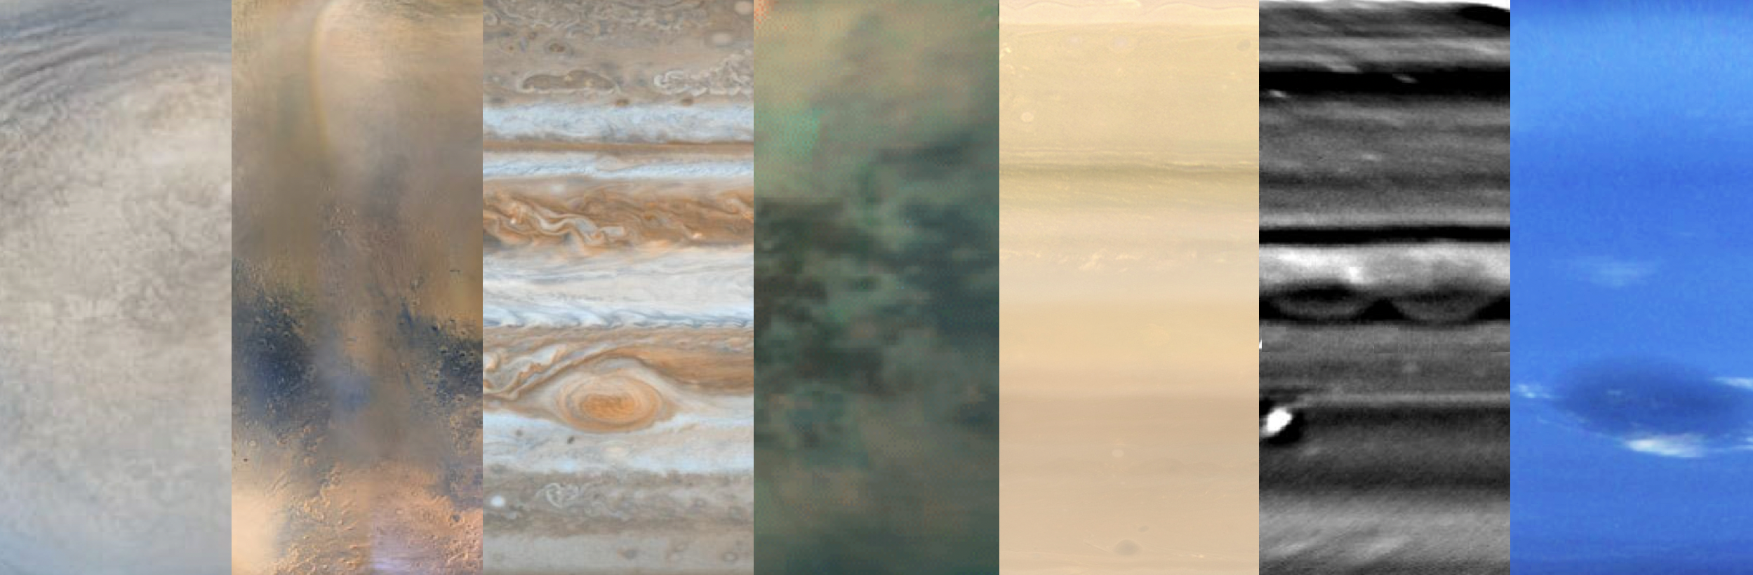

Figure 1 Montage of planetary atmospheres represented at the UKSSPA meeting, from left to right: Venus from Akatsuki, Mars from Mars Reconnaissance Orbiter, Jupiter from Cassini, Titan from Cassini, Saturn from Cassini, Uranus (from the Keck Observatory), and Neptune from Voyager 2.

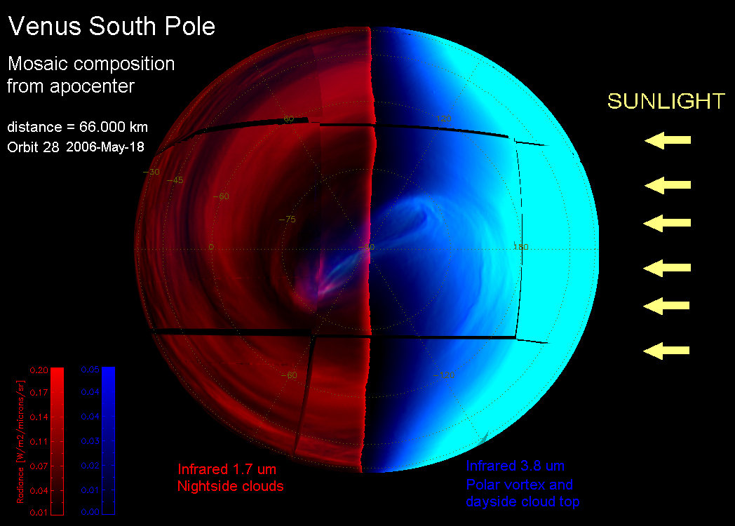

Figure 2 Venus’ polar dipole as observed by Venus Express VIRTIS instrument in 2006 (Credit: ESA/VIRTIS-VenusX IASF-INAF, Observatoire de Paris (A. Cardesín Moinelo, IASF-INAF) – full image here: <https://www.esa.int/ESA_Multimedia/Images/2007/11/Global_view_of_Venus_in_the_infrared>



Figure 3 Jupiter from Juno, showing how the atmosphere changes from the well-organised banded structure of low latitudes to the chaotic turbulence of the south polar domain (Credit: NASA / SwRI / MSSS / Gerald Eichstädt / Seán Doran) (full image: <https://www.flickr.com/photos/seandoran/35115224165/in/album-72157684110532315/>

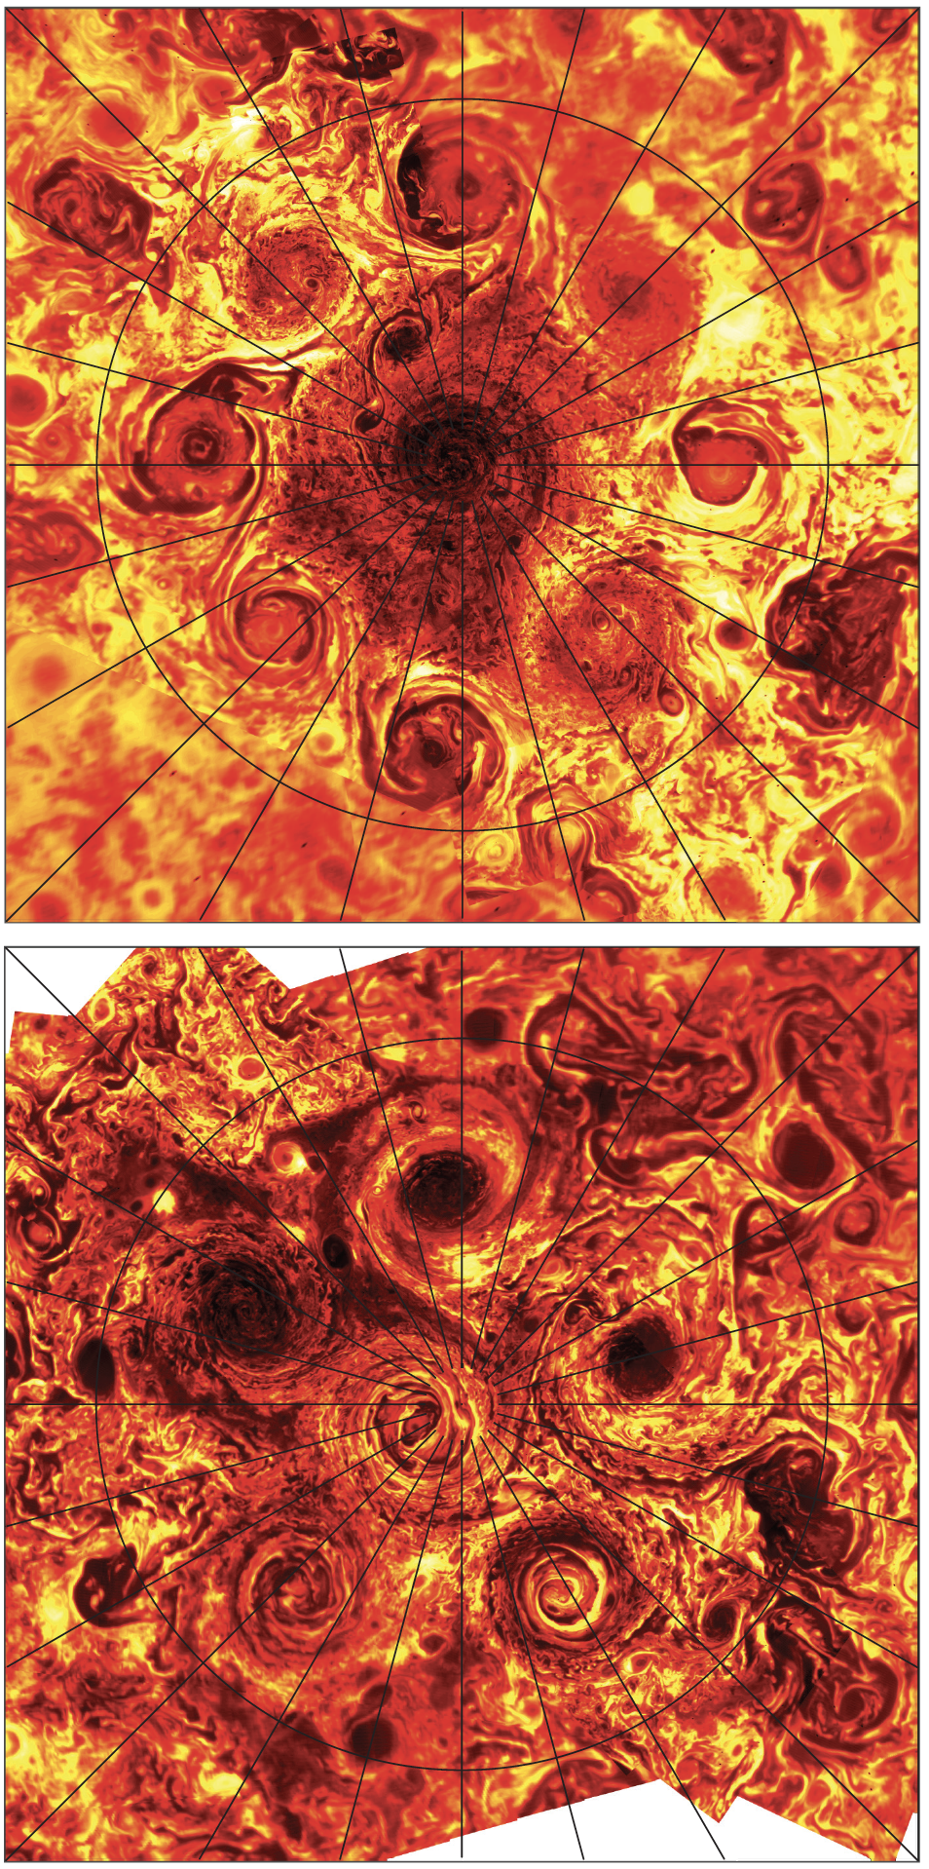

Figure 4 Jupiter’s poles in the infrared from Juno/JIRAM, showing cloudy regions as dark silhouettes against a bright background. A chain of eight cyclones encircle the north pole, compared to five cyclones in the south pole. (Credit: NASA/JPL-Caltech/SwRI/ASI/INAF/JIRAM, extracted from Adriani et al., 2018, doi:10.1038/nature25491)



Figure 5 Clouds rolling across the skies of Mars, as imaged by the Mars Insight lander in April 2019 )Credit: NASA/JPL-Caltech, full image: <https://mars.nasa.gov/resources/22441/insight-images-clouds-on-mars/?site=insight>)

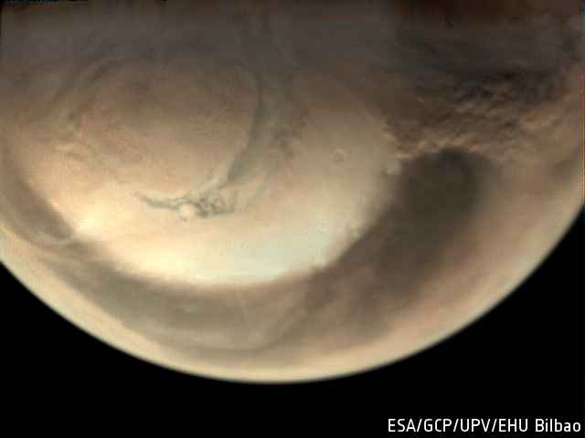

Figure 6 A dust storm underway at the edge of the north polar ice cap of Mars. The image was taken by the Mars Express Visual Monitoring Camera on 29 May 2019 (Credit: ESA/GCP/UPV/EHU Bilbao). Full image: <https://www.esa.int/Science_Exploration/Space_Science/Mars_Express/Dust_storms_swirl_at_the_north_pole_of_Mars>

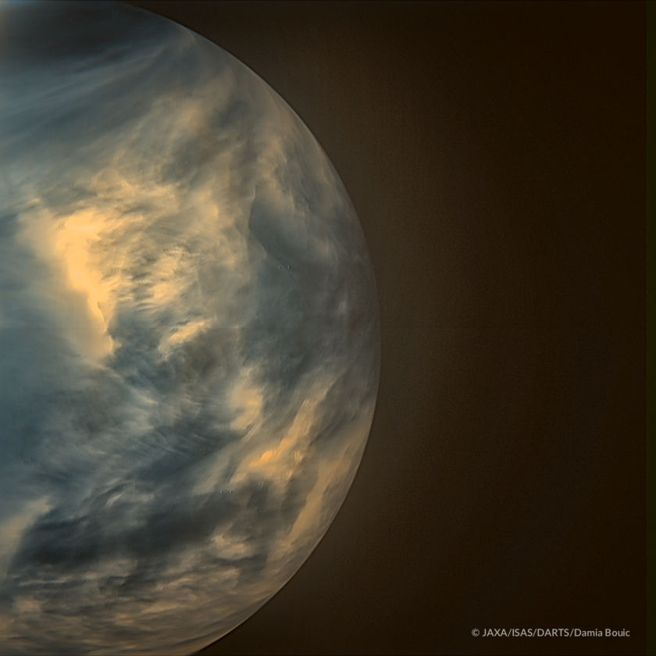

Figure 7 Venus acquired by the Japanese Akatsuki spacecraft's IR2 camera, which observes the "warmth" of the planet's atmosphere on its nocturnal side. (Credit: JAXA / ISAS / DARTS / Damia Bouic). Full image: <https://www.planetary.org/blogs/guest-blogs/2018/0116-a-new-look-at-venus-with-akatsuki.html>

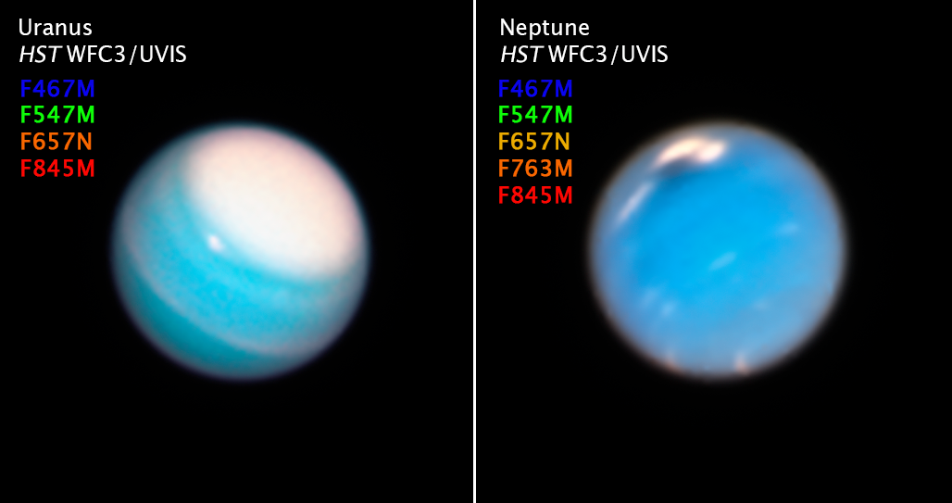

Figure 8 Uranus and Neptune in 2018 from the Hubble Space Telescope, revealing the polar cap of high reflectivity at Uranus’ north pole; and the dark oval and associated bright clouds in Neptune’s northern hemisphere. (CREDITS: NASA, ESA, A. Simon (NASA Goddard Space Flight Center), and M.H. Wong and A. Hsu (University of California, Berkeley). Full image: <https://hubblesite.org/contents/media/images/2019/06/4321-Image.html?news=true>

1. <https://en.wikipedia.org/wiki/Nimbus_program>
2. <https://www.theguardian.com/science/across-the-universe/2017/aug/18/how-nasas-voyager-spacecraft-changed-the-face-of-uk-science>
3. <https://en.wikipedia.org/wiki/Pioneer_Venus_Orbiter>
4. <https://www.cosmos.esa.int/web/voyage-2050>